

**Western Australian Certificate of Education**

**ATAR course examination, 2020**

**Question/Answer Booklet**

12 PHYSICS

Name

**Test 4 - Induced EMF**

|  |  |  |  |  |  |  |  |  |  |  |
| --- | --- | --- | --- | --- | --- | --- | --- | --- | --- | --- |
| Student Number: In figures |  |  |  |  |  |  |  |  |  |  |

**Mark: $\frac{}{\text{36}}$**  In words

#### Time allowed for this paper

Reading time before commencing work: five minutes

Working time for paper: fifty minutes

**Materials required/recommended for this paper**

To be provided by the supervisor

This Question/Answer Booklet

Formulae and Data Booklet

***To be provided by the candidate***

Standard items: pens, (blue/black preferred), pencils (including coloured), sharpener, correction fluid/tape, eraser, ruler, highlighters

Special items: non-programmable calculators satisfying the conditions set by the School Curriculum and Standards Authority for this course

**Important note to candidates**

No other items may be taken into the examination room. It is your responsibility to ensure that you do not have any unauthorised notes or other items of a non-personal nature in the examination room. If you have any unauthorised material with you, hand it to the supervisor before reading any further.

**Structure of this paper**

|  |  |  |  |  |  |
| --- | --- | --- | --- | --- | --- |
| Section | Number of questions available | Number of questions to be answered | Suggested working time  (minutes) | Marks available | Percentage of exam |
| Section One:  Short Answers |  |  |  |  |  |
| Section Two:  Problem-solving | 6 | 6 | 50 | 36 | 100 |
| Section Three:  Comprehension | - | - | - | - | - |
|  |  |  |  | **Total** | 100 |

**Instructions to candidates**

1. The rules for the conduct of examinations at Holy Cross College are detailed in the College Examination Policy*.* Sitting this examination implies that you agree to abide by these rules.

2. Write your answers in this Question/Answer Booklet.

3. Working or reasoning should be clearly shown when calculating or estimating answers.

4. You must be careful to confine your responses to the specific questions asked and to follow any instructions that are specific to a particular question.

5. Spare pages are included at the end of this booklet. They can be used for planning your

responses and/or as additional space if required to continue an answer.

• Planning: If you use the spare pages for planning, indicate this clearly at the top of the page.

• Continuing an answer: If you need to use the space to continue an answer, indicate in the original answer space where the answer is continued, i.e. give the page number. Fill in the number of the question(s) that you are continuing to answer at the top of the page.

6. Answers to questions involving calculations should be ***evaluated and given in decimal***

***form*.** It is suggested that you quote all answers to ***three significant figures***, with the

exception of questions for which estimates are required. Despite an incorrect final result, credit may be obtained for method and working, providing these are ***clearly and legibly set out***.

7. Questions containing the instruction "estimate" may give insufficient numerical data for their solution. Students should provide appropriate figures to enable an approximate solution to be obtained. Give final answers to a maximum of two significant figures and include appropriate units where applicable.

8. Note that when an answer is a vector quantity, it must be given with magnitude and direction.

9. In all calculations, units must be consistent throughout your working.

**Section A: Short Answer**

Marks Allocated: 21 marks out of 40 total marks.

This section has 7 questions. Answer the questions in the spaces provided.

**Question 1**

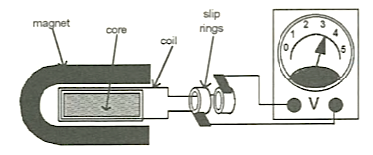

When the coil of the simple generator shown is turned, an EMF is induced. (No explanations are

required for the following questions.)

(a) What type of EMF is generated? (1 mark)

(b) How will increasing the rate of rotation of the coil affect the magnitude of the output EMF?

(1 mark)

(c) What is the source of the electrical energy induced in the coil? (1 mark)

**Question 2**

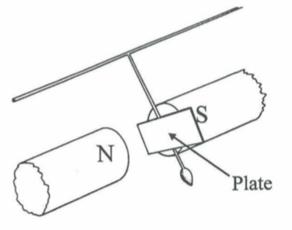

An oscillating pendulum can be brought to rest more rapidly (i.e. damped) by having an aluminium plate attached to it that passes between the poles of a magnet.

(a)  Describe the principle being employed here. (3 marks)

(b)  State ***two ways*** in which the damping may be ***increased***. (2 marks)

**Question 3**

In a satellite experiment during the 1990s, there was an attempt to stretch a wire between a space shuttle and a satellite at higher orbit to generate electricity. The wire was 20.7 km long and the voltage to be generated was 5.00 kV when the shuttle had a velocity of 7.92 kms-1. Find the magnitude of the component of the Earth's magnetic field perpendicular to the motion of the wire.

(4 marks)

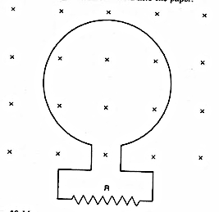**Question 4**

The diagram shows a conducting loop connected to a resistor R. The plane of the loop is at right-angles to the direction of the magnetic field directed into the paper.

(a) On the diagram, draw the direction of the induced current through R while the magnetic field density is ***increasing***? (1 mark)

(b) Given that the area of the loop is 1.00 x 10-2 m2 and the magnetic field density increases from 0.200 T to 0.500 T in 2.00 s, find the magnitude of the average induced EMF.

(3 marks)

**Question 5**

The diagram shows a simple AC alternator with the output connected to an oscilloscope and a light globe. The oscilloscope can be considered as having a very large resistance, so it does not impede the current flow. The coil (containing 10 loops) is 15.0 cm x 10.0 cm with the long side arranged into the page, and is rotated as shown. The magnetic field intensity of the magnets is 0.210 T.

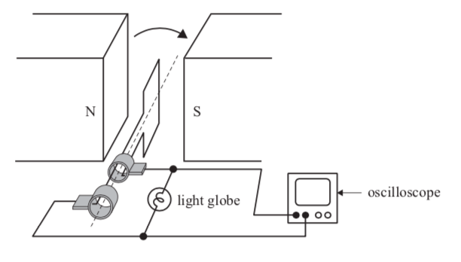

The maximum EMF of the coil as shown on the oscilloscope is represented below.

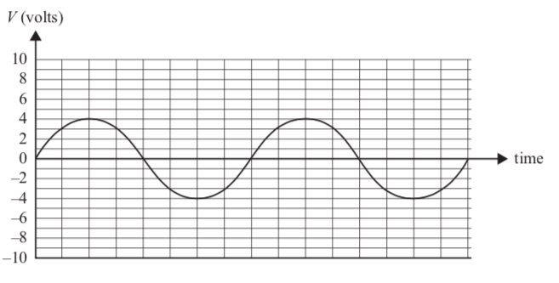

(a) At what frequency must the coil be rotated to achieve the output shown on the graph above?

(4 marks)

(b) Determine the EMFrms for the generator. (2 marks)

(c) The rate of rotation of the loop is ***doubled***. On the graph below, sketch the output that will now be seen on the oscilloscope. The original waveform is shown as a dashed line.

(2 marks)

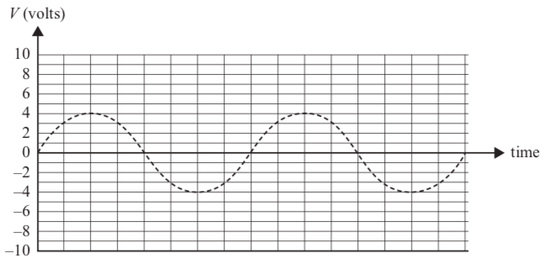

**Question 6**

A Physics class is investigating power loss in transmission lines.

The students construct a model of a transmission system. They first set up the model as shown in Figure 7. The model consists of a variable voltage AC power supply, two transmission lines, each of 4.00 Ω, a variable-ratio transformer (assume 100% efficient), a light globe and meters as needed. The purpose of the model is to operate the 4.00 V light globe.

A variable ratio transformer is one in which the ratio of turns in primary windings to turns in secondary windings can be varied. The resistance of the connecting wires can be ignored.

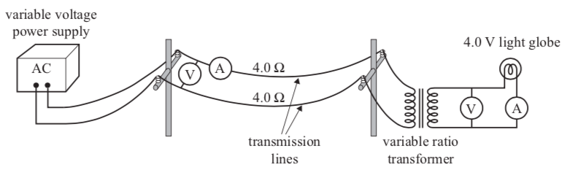

In their first experiment, the transformer is set on a ratio of 4:1 (primary:secondary) and the current in the transmission lines is measured to be 3.00 A. The light globe is operating correctly, with

4.00 V across it.

(a) Calculate the power dissipated in the light globe. Show your working. (4 marks)

(b) Determine the power loss in the transmission lines. (3 marks)

(c) Calculate the voltage output of the power supply. (3 marks)

(d) Suggest a reason high voltage are often used for the transmission of electric power over long distances. Explain your answer. (2 marks)